PowerSat CubeSat Mission Guide
STEMSat Educational CubeSat Program
Name: ____________________________
Team Members: ____________________________
Date: ____________________________
Mission Location: ____________________________

Mission Overview
In this mission, you will act as spacecraft power engineers.
Satellites in space rely on solar panels to generate energy from sunlight. However, energy is limited, and engineers must carefully manage how that energy is used. Satellites must decide which systems receive power and how to operate when energy is low.
Your CubeSat contains components that simulate how energy is generated and used so engineers can analyze how power affects system performance.
Your CubeSat includes the following sensors:
Component | What It Represents
Light Sensor Module (ALS-PT19) | Solar panel (light → energy input)
Accelerometer | Motion and orientation in three directions (X, Y, Z)
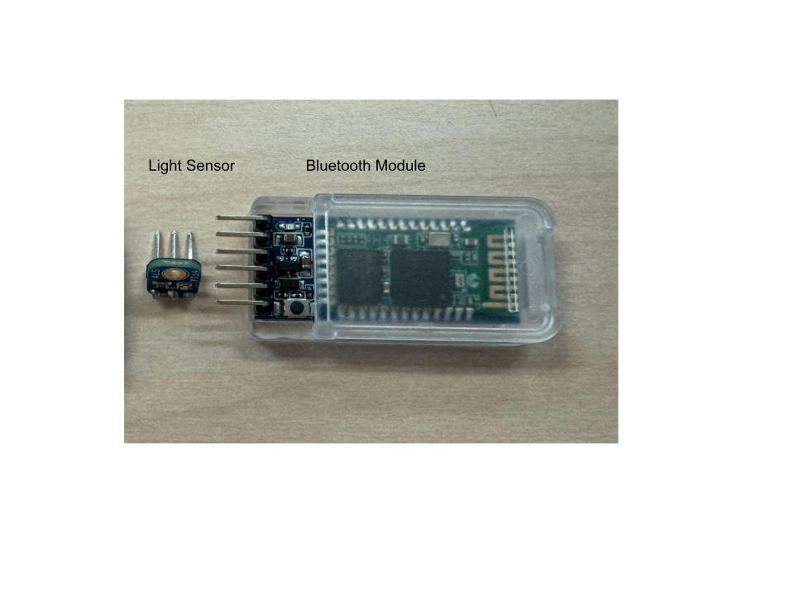
The CubeSat will send power system data to a computer, simulating how real satellites transmit telemetry data to ground stations.

Mission Question
How can a CubeSat generate and manage limited energy to keep important systems running?
Our Mission Question:

Step 1: Make a Hypothesis
Before testing your CubeSat, make a prediction.
Example:
We think the CubeSat will perform best in bright light because more energy is available to power the system.
Our Hypothesis:

Step 2: CubeSat Hardware Setup
Your CubeSat contains components that simulate a power system.
Component | Function
Light Sensor Module | Measures light level (energy input)

Step 3: Wiring the CubeSat
It is highly recommended that you follow along with this video, showing how to wire your sensors to your arduino sensor shield and run the code on the CubeSat!
Tutorial Video
The following wiring tables have been provided to help you follow along with the video/reference while wiring your sensors.
Connect the components to the Arduino using the female-to-female jumper wires.

Light Sensor (ALS-PT19)
Sensor Pin | Wire Color | Arduino Connection
+ | Red | A0 V
- | Black | A0 G
OUT | Green | A0 S
The light sensor will detect changes in light that the CubeSat experiences.

Bluetooth Module
Bluetooth Module | Wire Color | Arduino Connection
RXD | White | D11 S
TXD | Purple | D10 S
GND | Black | D10 V
VCC | Red | D10 G

Attach the Bluetooth module to the CubeSat so it can wirelessly transmit data to your computer.

Step 4: Insert the Code
Open the Arduino IDE and upload the Mission 3: PowerSat CubeSat program.
The program will:
- Read light level data
- Simulate available energy
- Calculate system state (ON, DIM, OFF)
- Send telemetry data to the computer
Example data output:
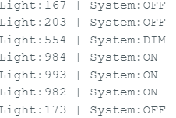
Each line represents a data packet transmitted by the CubeSat.

Step 5: Upload Code and Switch the CubeSat to Bluetooth Mode
After uploading the code, you must switch the CubeSat from programming mode to mission mode.
Follow these steps carefully.

1. Upload the Code
Upload the program using the USB cable connected to the Arduino.
Wait until the upload is complete.
2. Disconnect the USB Cable
Unplug the USB cable from the Arduino.
This step is important because the USB port and Bluetooth cannot communicate at the same time.

3. Turn on the CubeSat Power
Turn on the external battery pack connected to the CubeSat.
The CubeSat program will now begin running.

4. Connect to the CubeSat with Bluetooth
Open a Bluetooth terminal application on your computer.
Connect to the device named:
HC-05
If it is your first time connecting to it it may ask you to enter a port number, enter 1234. Your computer is now acting as the ground station for the CubeSat.
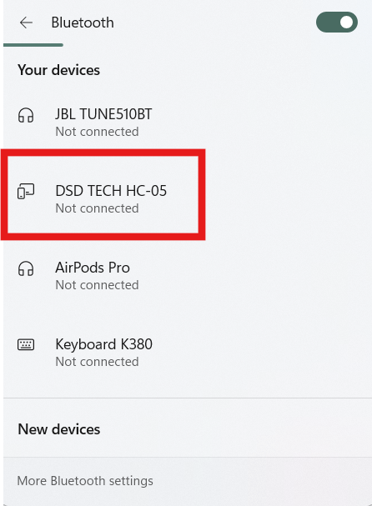

5. Select the Correct Port
Your computer will create a Bluetooth COM port when the HC-05 connects.
Select this port in your terminal program to view the CubeSat data.
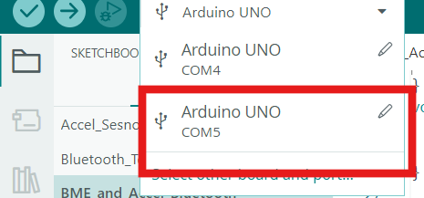
You should now see data packets like this in the serial monitor:


The numbers for light are the “counts” of lumens that the sensor is seeing; the higher the number, the higher lumens/brighter the light it is seeing!

CubeSat Operations Checklist
✔ Code uploaded successfully
✔ USB cable unplugged
✔ External battery pack turned on
✔ Bluetooth connected (if used)
Your CubeSat is now ready to collect mission data. Place the electronics onto the CubeSat.
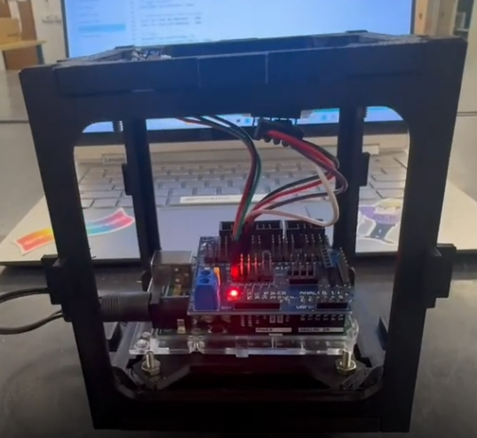

Step 6: Plan Your Investigation
Your team will perform three energy tests.
Examples include:
Test | Description
Bright Light Test | Shine flashlight directly on sensor
Dim Light Test | Use room lighting
Eclipse Test | Cover the sensor
Write your planned tests.
Test | Description
Test 1
Test 2
Test 3

Step 7: Data Collection
Record CubeSat data during each test.

Test 1
Test Name: _______________________
Trial | Light Level | System State (ON / DIM / OFF) | Notes
1
2
3

Test 2
Test Name: _______________________
Trial | Light Level | System State (ON / DIM / OFF) | Notes
1
2
3

Test 3
Test Name: _______________________
Trial | Light Level | System State (ON / DIM / OFF) | Notes
1
2
3

Step 8: Analyze Your Data
Which test produced the highest light level?

Which test caused the system to turn OFF or DIM?

What does this tell you about how energy affects a satellite?

Step 9: Graph Your Results
Create a graph of Light Level vs System State.
Sketch your graph below.
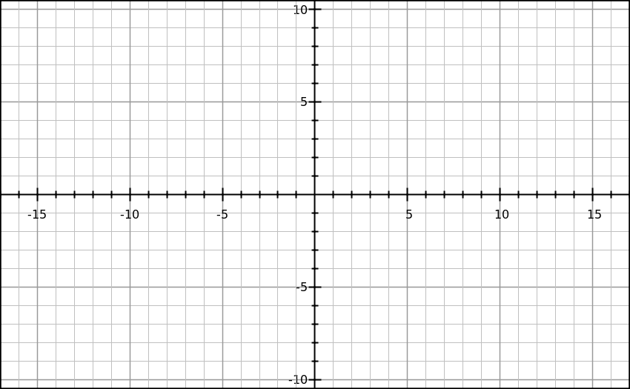

Step 10: Engineering Design Evaluation
Engineers must design satellites to manage limited energy.
Where is your “power source” located in your CubeSat?

Could system performance change if light conditions change?
☐ Yes
☐ No
Would reducing power demand improve performance?
☐ Yes
☐ No

Step 11: Improve Your CubeSat Design
Propose one improvement to your CubeSat system.
Examples:
- Reduce power usage
- Improve system efficiency
- Adjust how the system responds to low energy
Our Improvement Idea:

How would this improvement help the CubeSat manage energy better?

Step 12: Mission Reflection
Why do satellites need to carefully manage energy?

How does sunlight affect satellite performance?

What did your team learn from this mission?

Mission Success Checklist
☐ CubeSat responded to changes in light conditions
☐ Data was collected for multiple tests
☐ You analyzed energy system behavior
☐ You proposed a CubeSat design improvement

Connect to Real Satellites
Real satellites rely on power systems to operate in space. Engineers manage energy to:
- Generate power using solar panels
- Store energy in batteries
- Decide which systems receive power
- Operate during periods of low or no sunlight
Your CubeSat uses the same basic idea — collecting data about energy input and making decisions based on limited power.

